**THE TABLEAU HR SCORECARD: MEASURING SUCCESS IN TALENT MANAGEMENT**

**1. INTRODUCTION**

The introduction of the Tableau HR Scorecard is designed to bring a data-driven and visual approach to HR management. This allows HR professionals and leadership to monitor and analyze talent-related data more effectively, ultimately leading to better decision-making, enhanced employee satisfaction, and improved overall organizational performance. It aligns HR strategies with the broader business objectives, making it an essential tool for modern HR departments seeking to optimize their talent management processes.

* 1. **OVERVIEW**

An HR scorecard is a tool used by Human Resources departments to measure and track various key performance indicators (KPIs) related to talent management. These KPIs help HR professionals and business leaders assess their HR strategies and practices.

* 1. **PURPOSE**

The scorecard ensures that HR strategies and practices are aligned with the broader goals and objectives of the organization. It helps bridge the gap between HR activities and the overall success of the company.

**2. PROBLEME STATEMENT & DESING THINKING**

"The current talent management system lacks a comprehensive and data-driven method for assessing and improving HR performance, talent acquisition, and retention. There is a need to develop a Tableau HR Scorecard to measure and visualize success in talent management."

* Start by understanding the pain points and challenges faced by HR and management in talent management.
* Conduct interviews, surveys, and workshops with HR professionals and managers to gather insights.

**2.2 EMPATHY MAP**

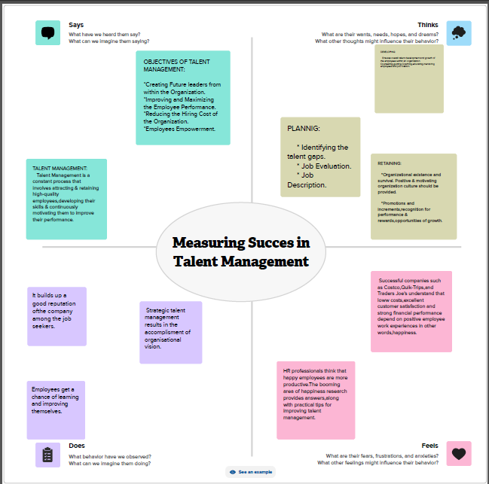

**2.3 IDEATION & BRAINSTROMING**

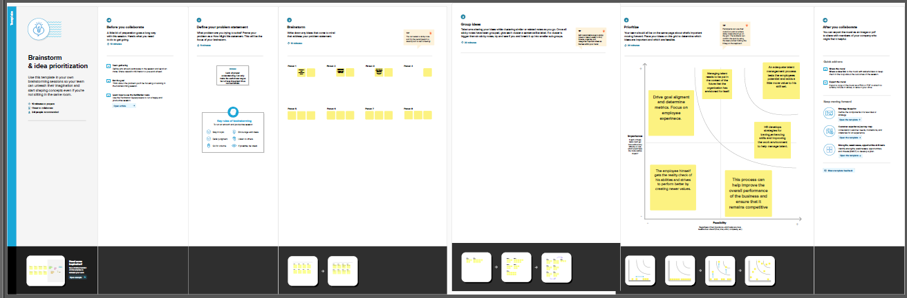

**3. RESULT**

**3.1 KPI**

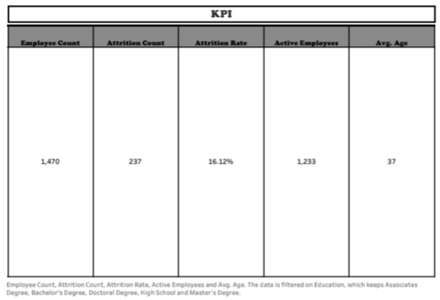

**3.1.2 ATTRITION BY GENDER**

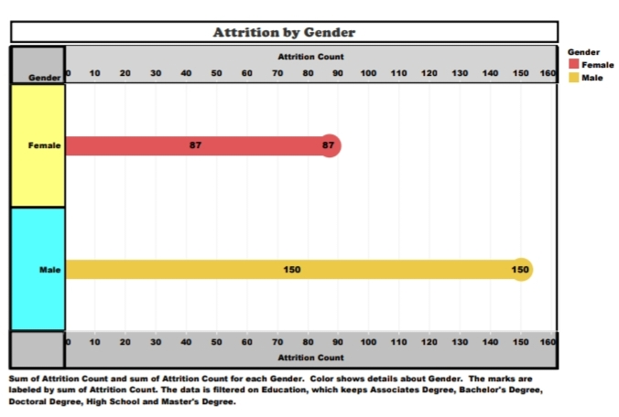

**3.1.3 DEPARTMENT WISE ATTRITION**

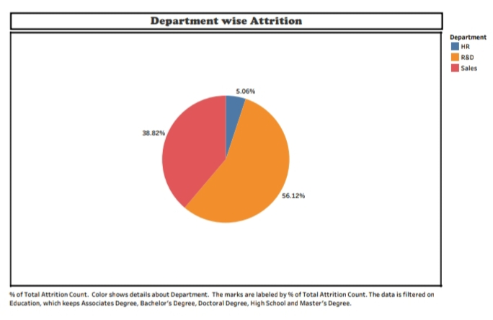

**3.1.4 NO. OF EMPLOYEES BY AGE GROUP**

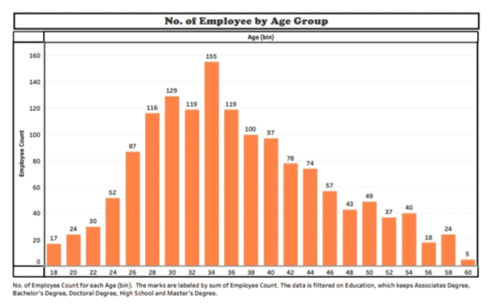

**3.1.5 JOB SATISFACTION RATING**

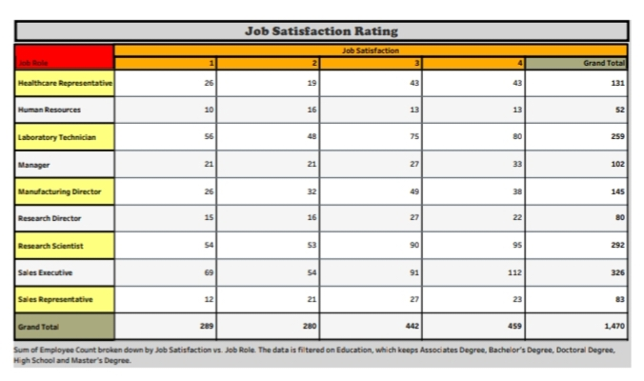

**3.1.6 EDUCATION FIELD WISE ATTRITION**

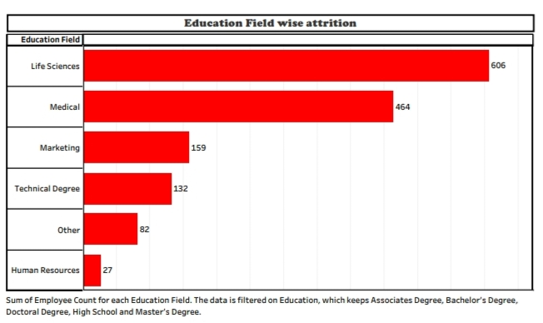

**3.1.7 ATTRITION RATE BY GENDER FOR DIFFERENT AGE GROUP**

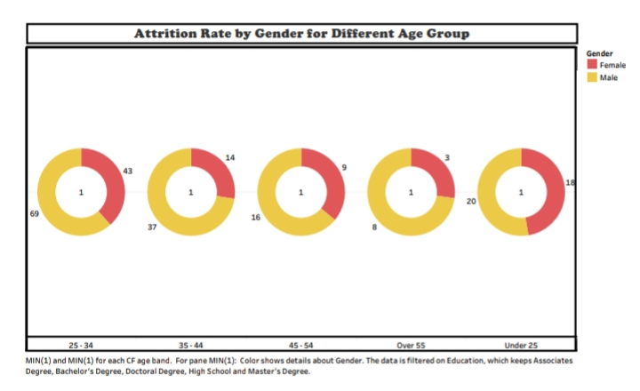

**DASHBOARD**

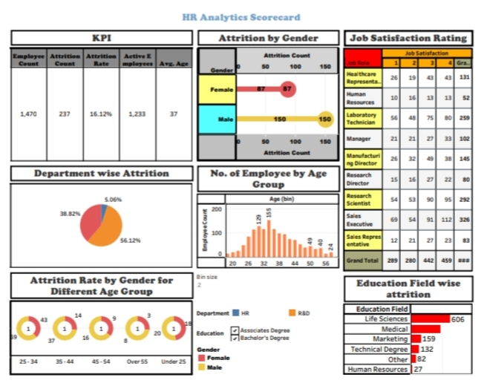

**STORY**

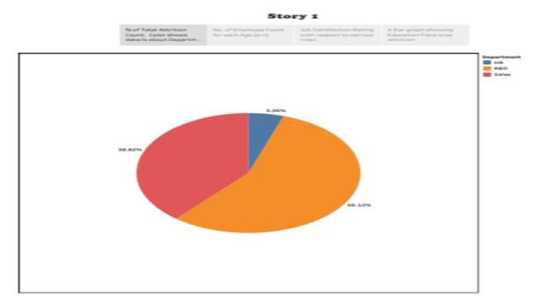

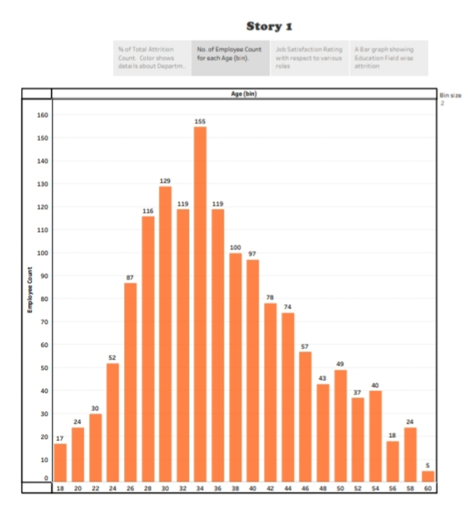

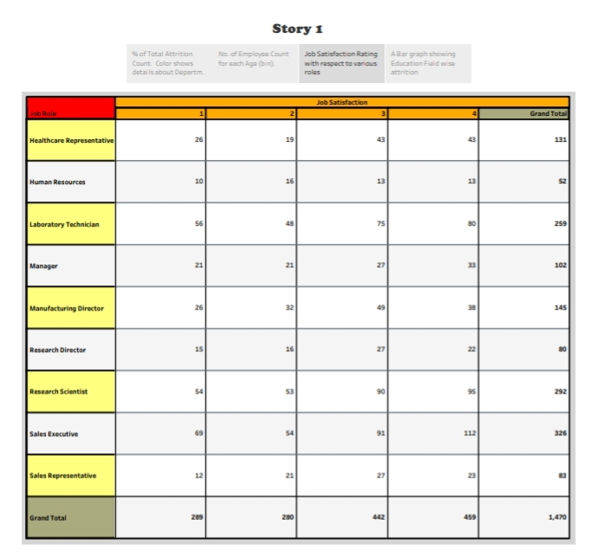

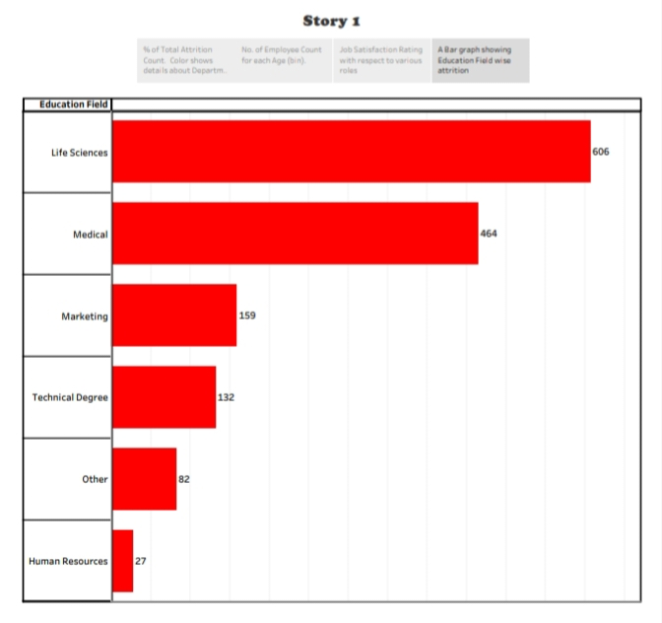

**4.1 ADVANTAGES**

1. **Data-Driven Decision Making:** The scorecard provides HR professionals and management with access to data and analytics that can inform strategic decisions. It allows for evidence-based decision-making rather than relying on intuition or anecdotal evidence.
2. **Visual Insights:** Tableau's data visualization capabilities enable users to quickly and easily grasp trends, patterns, and anomalies within the talent management data. Visualizations make complex data more accessible and understandable.
3. **Customization:** Tableau allows for the creation of custom dashboards and reports tailored to the specific needs of an organization. Users can design visualizations that align with their unique talent management objectives and KPIs.
4. **Real-Time Monitoring:** With Tableau, data can be updated in real-time or at frequent intervals, enabling organizations to monitor HR performance and talent management outcomes continuously. This timely information is critical for addressing issues promptly.
5. **Alignment with Organizational Goals:** The HR Scorecard can be designed to align with an organization's broader strategic goals, ensuring that talent management efforts support the company's overall mission and objectives.
6. **Transparency:** The scorecard promotes transparency by making HR performance and talent management data available to stakeholders across the organization. This transparency can foster accountability and improve communication.
7. **Identifying Areas for Improvement:** By tracking key metrics related to talent acquisition, retention, and performance, organizations can pinpoint areas that require improvement. This can lead to targeted interventions to enhance talent management strategies.
8. **Cost Savings:** Efficient talent management can lead to cost savings by reducing turnover, improving recruitment processes, and optimizing training and development efforts. The scorecard helps identify cost-saving opportunities.
9. **Benchmarking:** Organizations can compare their HR and talent management performance to industry benchmarks or historical data, allowing for competitive analysis and insights into where they stand relative to their peers.
10. **Employee Engagement:** Effective talent management positively impacts employee satisfaction and engagement, leading to higher productivity and retention rates. The HR Scorecard can highlight areas where improvements in employee engagement can be made.
11. **Long-Term Success:** A well-designed HR Scorecard encourages a focus on long-term success, as it enables organizations to set goals, track progress, and make necessary adjustments over time.
12. **Compliance and Legal Protection:** By tracking key HR metrics, organizations can demonstrate their commitment to fair and compliant HR practices, reducing the risk of legal issues related to discrimination or unfair treatment.

**4.2 DISADVANTAGES**

1. **Implementation Costs:** Setting up a Tableau HR Scorecard can be costly, including expenses for software licenses, data integration, and training. Smaller organizations with limited budgets may find it challenging to afford the initial investment.
2. **Data Quality and Availability:** The accuracy and availability of HR data are critical. If data is incomplete, inaccurate, or inconsistent, it can lead to unreliable insights. Maintaining data quality can be resource-intensive and time-consuming.
3. **Complexity:** Building and maintaining Tableau dashboards and reports can be complex, especially for users with limited technical expertise. Organizations may require dedicated personnel or training to develop and manage these tools effectively.
4. **Data Privacy and Security:** Handling sensitive HR data requires stringent security measures to protect employee privacy and comply with data protection regulations. A data breach or misuse of data can have serious legal and reputational consequences.
5. **Resistance to Change:** Implementing a Tableau HR Scorecard may face resistance from employees who are accustomed to traditional HR practices. Change management efforts are often required to ensure adoption and acceptance.
6. **Overemphasis on Metrics:** Overreliance on metrics can lead to a narrow focus on quantitative data, potentially neglecting qualitative factors that influence talent management, such as culture, leadership, and employee well-being.
7. **Metric Selection Challenges:** Selecting the right metrics and KPIs for the scorecard can be difficult. Choosing the wrong metrics can lead to misguided decisions and strategies that do not address the organization's true talent management needs.
8. **Lag Time in Data Reporting:** Real-time data reporting is not always feasible, and there may be a time lag between data collection and reporting. This can limit the organization's ability to respond promptly to talent management issues.
9. **Data Overload:** Excessive data and visualizations can overwhelm users, making it challenging to focus on the most critical HR performance indicators. Simplicity in design is crucial for effective communication.
10. **Maintenance and Updates:** The HR Scorecard requires ongoing maintenance and updates to ensure its relevance and accuracy. Changes in HR practices or the organization's goals may necessitate updates to the scorecard.
11. **Lack of Context::** Data in isolation may lack context, and without a thorough understanding of the organization's unique dynamics, users may misinterpret HR metrics.
12. **Unintended Consequences:** Overemphasis on certain metrics may lead to undesirable behaviors or gaming the system, as employees and managers may prioritize metrics at the expense of other important factors.
13. **Risk of Micromanagement:** Over-monitoring HR metrics can lead to micromanagement of HR processes, which may hinder creativity and innovation and lead to increased stress among employees.

**APPLICATION**

1. **Talent Acquisition:**
   * **Recruitment Analytics:** Use the scorecard to track metrics like time-to-fill, cost-per-hire, and source effectiveness to optimize recruitment strategies.
   * **Candidate Quality:** Measure the quality of candidates and identify the sources that yield the best-fit employees.
2. **Employee On boarding:** 
   * **On boarding Effectiveness:** Assess the on boarding process's efficiency by tracking new hire satisfaction, time to productivity, and compliance with on boarding requirements.
3. **Employee Engagement and Retention:**
   * **Engagement Surveys:** Integrate survey data to monitor employee engagement and satisfaction levels, identifying areas for improvement.
   * **Turnover Rates:** Track and analyze turnover rates and the reasons for employee departures to address retention issues.
4. **Performance Management:**
   * **Performance Metrics:** Monitor individual and team performance, including goal achievement, performance appraisals, and feedback processes.
5. **Training and Development:**
   * **Training ROI:** Measure the return on investment (ROI) for training and development programs by tracking skill development and performance improvement.
6. **Diversity and Inclusion:**
   * **Diversity Metrics:** Monitor diversity and inclusion efforts by tracking demographics, hiring of underrepresented groups, and analyzing diversity at different organizational levels.
7. **Compensation and Benefits:**
   * **Compensation Analysis:** Analyze salary structures, bonuses, and benefits to ensure they are competitive and aligned with industry standards.
   * **Benefits Utilization:** Track the usage of benefits and wellness programs to optimize offerings.
8. **Succession Planning:**
   * **Talent Pipeline:** Identify high-potential employees and track their development to ensure a robust succession plan for leadership positions.
9. **Workforce Planning:**
   * **Skill Gap Analysis:** Analyze skill gaps in the workforce and implement strategies for upskilling or hiring to address them.
10. **Compliance and Legal Considerations:**
    * **Data Compliance:** Ensure compliance with data privacy and employment regulations by tracking and reporting on compliance-related metrics.
11. **Benchmarking and Industry Comparisons:**
    * **Peer Comparison:** Compare HR metrics with industry benchmarks to understand where the organization stands relative to competitors and peers.
12. **Management Reporting:**
    * **Executive Dashboards:** Provide management with real-time dashboards to monitor key HR metrics, enabling proactive decision-making.

**CONCLUSION**

**However, it's important to acknowledge the potential disadvantages and challenges associated with implementing a Tableau HR Scorecard. These include implementation costs, data quality concerns, complexity, and the risk of overemphasizing metrics at the expense of qualitative factors. To overcome these challenges, organizations must invest in data quality, user training, and change management.**

**The application of a Tableau HR Scorecard spans various HR functions, from talent acquisition to employee engagement, and from performance management to workforce planning. It provides a holistic view of an organization's talent management processes, enabling better decision-making and ultimately contributing to long-term success.**

**As organizations continue to recognize the value of data-driven HR practices, the Tableau HR Scorecard serves as a valuable tool in their pursuit of effective talent management, cost control, and strategic HR planning. By embracing this approach and adapting it to their specific needs, organizations can position themselves for a more competitive and successful future in the ever-evolving world of human resources.**

**FUTURE SCOPE**

1. **Advanced Analytics:** As technology advances, HR departments will increasingly use predictive and prescriptive analytics to anticipate HR trends and proactively address talent management issues. Machine learning and AI algorithms within Tableau can provide deeper insights into workforce planning and employee behavior.
2. **Integration with Other HR Technologies:** Tableau HR Scorecards will integrate more seamlessly with other HR technologies and platforms, such as HRIS (Human Resource Information Systems), applicant tracking systems, and learning management systems, creating a more holistic view of HR data.
3. **Personalized Employee Insights:** HR Scorecards may provide personalized insights for individual employees, enabling them to track their own performance and development progress. This can enhance employee engagement and self-driven improvement.
4. **Global Talent Management:** Organizations with a global presence will expand the use of Tableau HR Scorecards to analyze and manage talent across multiple countries and regions, considering cultural nuances, legal requirements, and market dynamics.
5. **Workforce Analytics Centers of Excellence:** Some organizations will establish dedicated workforce analytics teams or centers of excellence to focus on HR data analysis, fostering a data-driven culture within the HR department.
6. **Employee Experience Management:** HR Scorecards will increasingly focus on measuring and enhancing the overall employee experience, covering aspects like work-life balance, well-being, and diversity and inclusion, to create a more positive workplace culture.
7. **Real-Time Feedback and Surveys:** The integration of real-time feedback tools and sentiment analysis within Tableau will allow organizations to continuously gauge employee sentiments, making it easier to respond to concerns and adapt talent management strategies in real time.
8. **Enhanced Data Security:** With growing concerns about data privacy and security, future HR Scorecards will include advanced security measures to protect sensitive HR data from unauthorized access or breaches.
9. **Robust Mobile Capabilities:** Mobile-friendly versions of HR Scorecards will enable HR professionals and employees to access and interact with HR data and insights on the go.
10. **Artificial Intelligence and Natural Language Processing:** AI and NLP capabilities will enable more intuitive and conversational interactions with HR data, making it easier for users to query and analyze data.
11. **Integration with Organizational Goals:** HR Scorecards will continue to be closely aligned with an organization's strategic objectives, ensuring that HR efforts support the overall mission and vision of the company.
12. **Regulatory Compliance:** As labor laws and regulations evolve, HR Scorecards will adapt to ensure compliance and reporting in accordance with changing legal requirements.

**APPENDIX**

1. **Recruitment Metrics:**
   * Time-to-Fill
   * Cost-per-Hire
   * Quality of Hire
   * Source Effectiveness
2. **Onboarding Metrics:**
   * New Hire Satisfaction
   * Time to Productivity
   * Compliance with Onboarding Requirements
3. **Employee Engagement and Retention Metrics:**
   * Employee Engagement Scores
   * Turnover Rates
   * Exit Interview Analysis
4. **Performance Management Metrics:**
   * Goal Achievement
   * Performance Appraisal Ratings
   * Feedback and Coaching Metrics
5. **Training and Development Metrics:**
   * Training ROI
   * Skill Development Progress
   * Training Completion Rates
6. **Diversity and Inclusion Metrics:**
   * Diversity Demographics
   * Representation in Leadership
   * Inclusion Survey Scores
7. **Compensation and Benefits Metrics:**
   * Salary Structure Analysis
   * Benefits Utilization
   * Compensation Competitiveness
8. **Succession Planning Metrics:**
   * High-Potential Employee Identification
   * Succession Pipeline Health
9. **Workforce Planning Metrics:**
   * Skill Gap Analysis
   * Workforce Demographics
   * Recruitment Forecast
10. **Compliance and Legal Metrics:**
    * Compliance with Labor Laws
    * Equal Employment Opportunity (EEO) Metrics